**CAMBRIDGE INSTITUTE OF TECHNOLOGY**



***-***

***Innovation Manifested***



**Unveiling the Technologies, Talents and Hobbies**

**DEPARTMENT OF COMPUTER SCIENCE AND ENGINEERING**

# PROJECT TITLE : women safety device

**ABSTRACT:**

The project presents a wearable safety device for women using the BOLT IOT. The purpose of this device is to safeguard women in the event they might face any danger. The device uses wireless sensor network to communicate to activate device. The GPS and GSM are used to share the user’s location directly to the relevant authorities and saved contacts(working on this technology). The switch in the device work for activating the device manually in case of emergency. This device will be fixed in the shoes.

**DESCRIPTION OF THE PROJECT:**

This device will be fixed to the shoes and it is detachable, device can be charged when not in use. This gives shock to the unknown person wherever the person tries to touch. This can be activated through mobile whenever the person feels unsafe.

Components used:- bolt iot, stepup voltage converter, rechargeable Li battery.

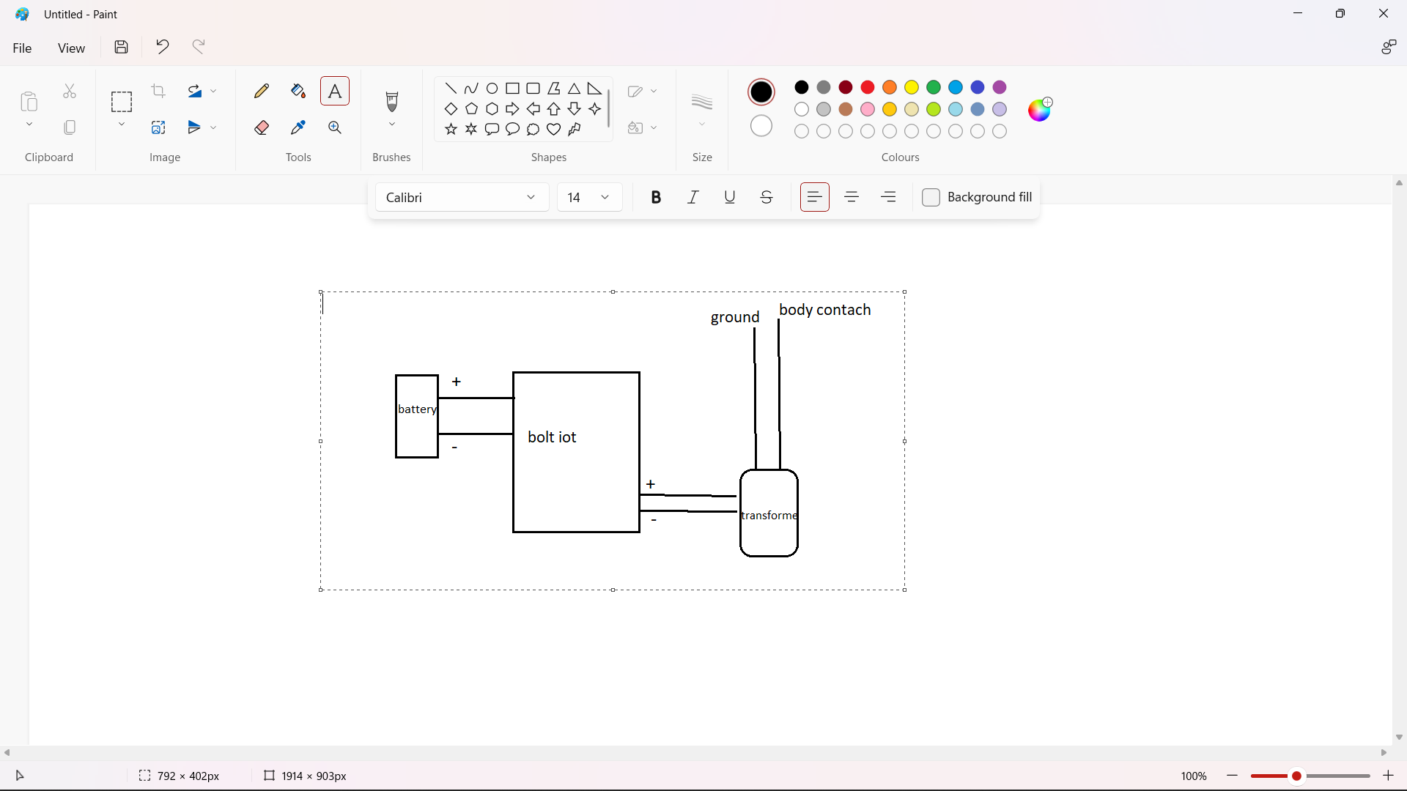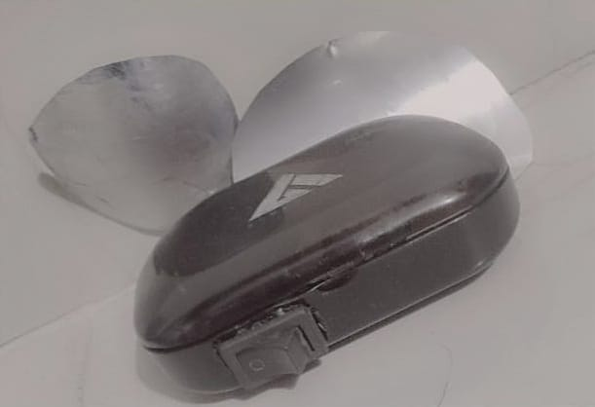

|  |  |
| --- | --- |
| **TEAM MEMBERS WITH USN** | **PROJECT GUIDE/COORDINATOR:** |
|  |  |
| **1)D.Manoj 1CD21AI010** | **1)** Prof. Yashaswini S |
| **2)Harsh taylor 1CD21AI018**  **3)Bhumika 1CD21CS026** |  |